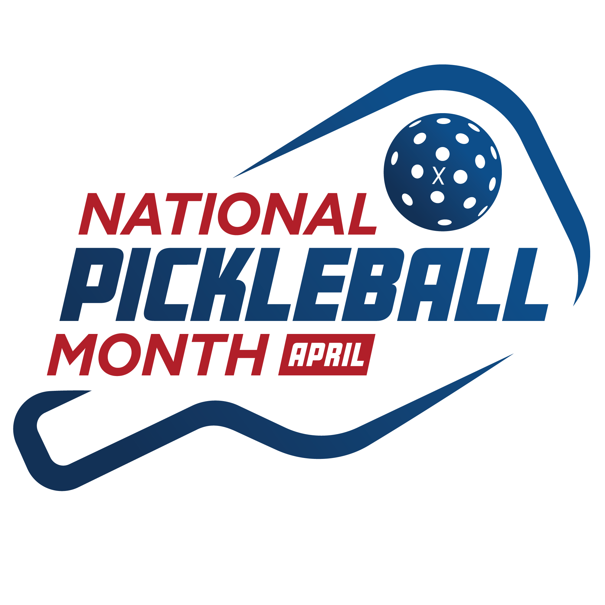
USA Pickleball Kicks Off 2024 National Pickleball Month

The National Governing Body initiated the annual month-long celebration of the fastest-growing sport in America

PHOENIX (April 1, 2024) — USA Pickleball, the National Governing Body for the sport, today kicked off celebrations and activations for National Pickleball Month throughout April.
Established in 2018, National Pickleball Month is designed to connect everyone within the sport while, at the same time, introduce pickleball to new audiences by highlighting its inclusive, fun and healthy qualities.
“It’s my pleasure to wish our community a very happy National Pickleball Month! We could not be more excited to kick off the sixth annual National Pickleball Month as we continue to reach new heights within our sport and observe continued growth across all aspects of pickleball,” said Mike Nealy, USA Pickleball Chief Executive Officer. “While our team at USA Pickleball views every month as Pickleball Month, we are delighted to engage with our members to truly celebrate the many different aspects of our sport this April. I look forward to the festivities ahead!”
In conjunction with Pickleball Month, USA Pickleball also announced the launch of the organization’s official charitable arm, “USA Pickleball Serves”. The mission of USA Pickleball Serves is to make a positive national impact through the sport of pickleball by supporting community initiatives like court enhancements, educational youth programming and inclusive play.
USA Pickleball announced its plans to celebrate people, places and events across the sport using weekly themes during the month of April that focused on different topics. The themes are as follows:
April 1-8 – Why We Love Pickleball
April 9-15 – Up Your Game
April 16-22 – Member Appreciation
April 23-30 – What's Next/Looking Ahead
To share your love for pickleball, make sure to tag USA Pickleball on Facebook, Instagram, X, and LinkedIn using the hashtag #PickleballMonth.
Submit storylines and/or photos surrounding your pickleball journey or experience on our website here.
For more information about National Pickleball Month and pickleball, visit usapickleball.org.
###

About USA Pickleball
USA Pickleball is the National Governing Body (NGB) for the sport of pickleball in the United States. Its mission is to promote the development and growth of the sport while sanctioning events and providing annual members with premier tournaments, educational opportunities, player rankings, official rules and other exclusive benefits. USA Pickleball is a nonprofit 501(c)(3) corporation that is governed and operated by a Board of Directors and a national office staff, who provide the guidance and infrastructure for the continued expansion of the sport.

USA Pickleball Media Contact:
Melissa Zhang, Director of Communications & Content
mzhang@usapickleball.org

