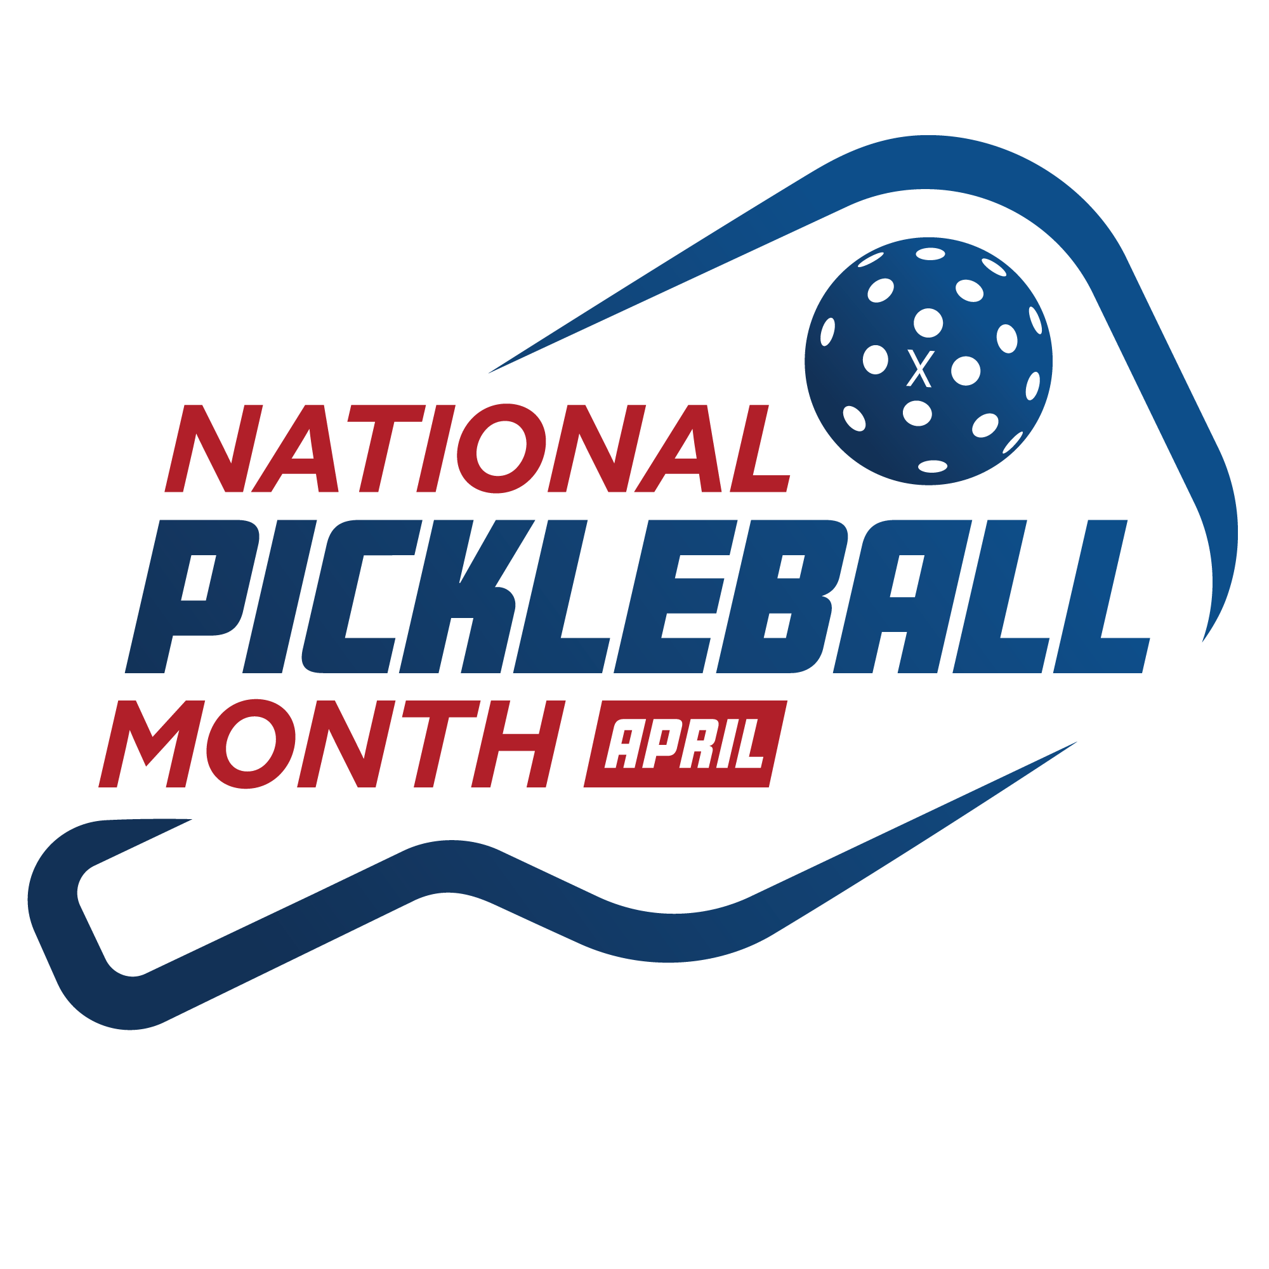
Please see below for a list of helpful links you may need during National Pickleball Month to provide further information or answer questions:

- USA Pickleball Social Media
  - Facebook
  - Twitter
  - Instagram
  - LinkedIn
  - YouTube
  - TikTok
- National Pickleball Month
  - National Pickleball Month landing page
  - Press Release – link will be published on April 1
- Growth of Pickleball
  - USA Pickleball Annual Growth Report
  - Sports & Fitness Industry Association data from 2024
- USA Pickleball Serves
  - USA Pickleball Serves landing page
  - Press Release – link will be published on March 28
- USA Pickleball/Pickleball PSA Videos
  - Why You Should Become A USA Pickleball Member
  - You Have To Try This Sport - Pickleball

