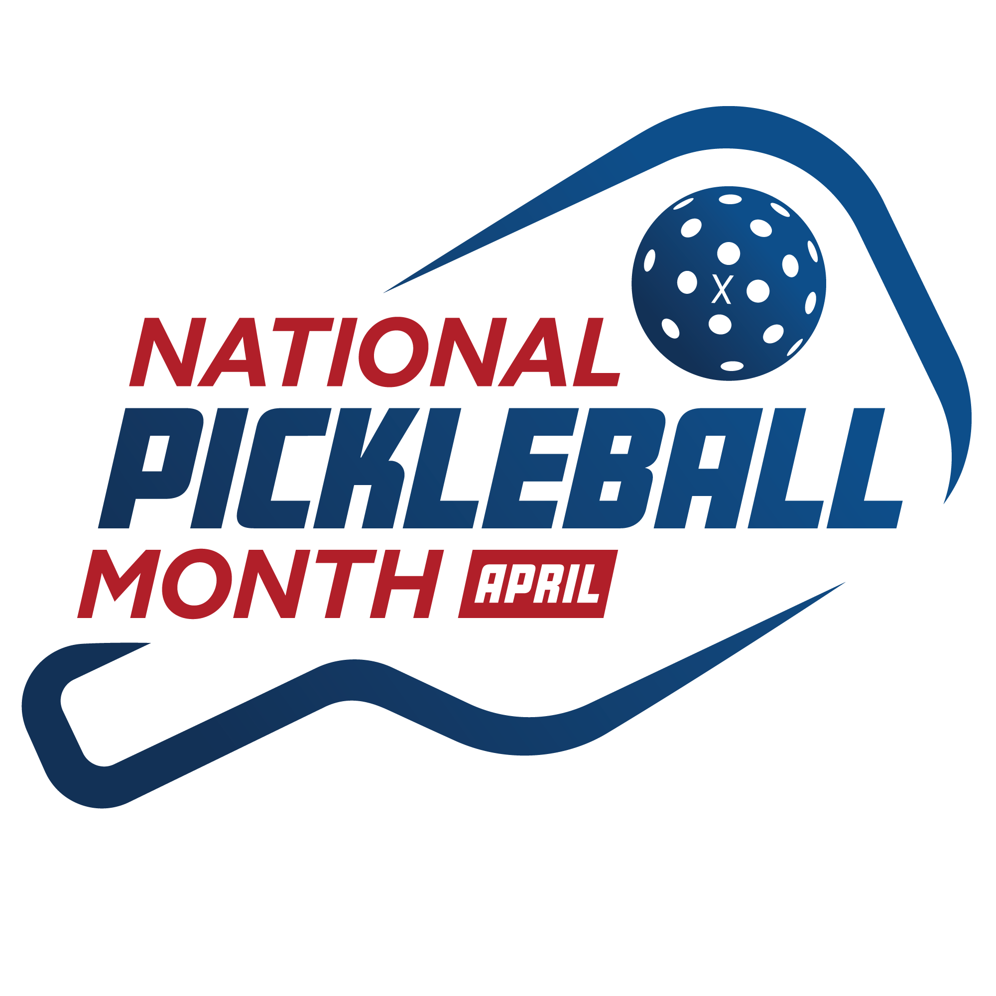
USA Pickleball is leading the celebrations for National Pickleball Month during the month of April! The program is optional and not mandatory for ambassadors to facilitate but is highly encouraged. We believe the program has huge potential and we are providing our ambassadors with some helpful tools that can be used to promote the concept through their local clubs and pickleball groups as a way to help drive local awareness and participation.

The goal is to promote the sport with social media, local outreach and news coverage, free or reduced-rate introductory classes, outreach clinics, skill sessions, etc. Basically anything you and your club can coordinate in your market. The fact it's a month-long event means you have an entire 31 day window to find a time(s) that work with your group and your facility. Some clubs will want to run multiple events while others will run just one - it's completely up to you how much you want to put into this.

Once you determine your game plan, the following "toolkit" items are available for you to market your planned event(s) -- good luck!
____________________________________________________________________________
Why National Pickleball Month?
- NPM is a “rallying point” for the sport of pickleball
- It promotes the sport to all consumers, of all ages
- It promotes the sport to park & recs, facilities, clubs, etc.
- NPM is a catalyst for business, including sports facilities, teaching professionals, retailers, court builders and manufacturers
- It serves as a platform to promote pickleball on a local level
- NPM strengthens the sport’s local connections through awareness and advocacy
- It is a platform for telling about all the good things pickleball can do for people
- It is a national platform to show how pickleball is the fastest growing sport in the U.S.
- Early spring, as players in the northern part of the country are hitting the outdoor courts, or returning from snowbird locations
- Programs and leagues are being formed for summer play
- Anticipates/previews National Physical Fitness & Sports Month in May
____________________________________________________________________________
National Pickleball Month logos
We’ve provided the National Pickleball Month logos in varied formats and colors/styles in the toolkit for you to use while spreading the word about National Pickleball Month to your community.
____________________________________________________________________________
National Pickleball Month hashtag

When posting on social media about National Pickleball Month, please use the hashtag #PickleballMonth and tag USA Pickleball in all of your posts and stories! USA Pickleball will be trying to reshare and amplify as much of the content from this hashtag as possible, so please let people know that this is the hashtag they should be using.
____________________________________________________________________________
Graphics
Please see a graphics folder in the toolkit for a set of graphics and visuals that you may use in your outreach efforts as well.
____________________________________________________________________________
Press Release
USA Pickleball will distribute a press release (which can be found in the toolkit) announcing National Pickleball Month on April 1, letting them know about the plans and efforts around the event. We encourage you to share this release in a more formal capacity with those who could benefit from learning more about USA Pickleball and National Pickleball Month (ie. local businesses, media outlets, politicians, etc.)
____________________________________________________________________________
USA Pickleball Serves
In conjunction with National Pickleball Month, USA Pickleball announced the launch of its official charitable arm, USA Pickleball Serves. The mission of USA Pickleball Serves is to make a positive national impact through the sport of pickleball by supporting community initiatives like court enhancements, educational youth programming and inclusive play.

In conjunction with National Pickleball Month and the announcement, USA Pickleball will host an introductory pickleball clinic at Arizona Athletic Grounds for 120 Mesa students on April 2, the day before the USA Pickleball Golden Ticket tournament in Mesa. The clinic will be followed by several exhibition matches with professional players.

Find more information about USA Pickleball Serves on our website.
____________________________________________________________________________
USA Pickleball/Pickleball PSA Videos
Why You Should Become A USA Pickleball Member
You Have To Try This Sport - Pickleball
____________________________________________________________________________
Why April?
- Early spring, as players in the northern part of the country are hitting the outdoor courts, or returning from snowbird locations
- Programs and leagues are being formed for summer play
- Anticipates/previews National Physical Fitness & Sports Month in May
____________________________________________________________________________

Promote Health and Fitness
Promote pickleball as the perfect sport for families and players of all ages looking to be active and get healthy. NPM also can tie into other health-related events in April, including:
- National Public Health Week — April 3-9
- Defeat Diabetes Month
- World Health Day - April 7

